**Project 5**

**Data Integration using Talend**

**Name: Adeel Nasir (gd8408)**

Data Source: we will use “Orderline.csv” and “Product.csv” in this assignment. There are three columns: “OrderID”, “ProductID” and “Quantity” in Orderline data set and three columns: “ProductID”, “ProductName” and “Price” in the Product data set. The matched key column is “ProductID”.

Task 1: Sort and Filter

a. Import Product.csv into the Talend data studio job.

b. Filter the records from Product based on the value of Price. If the price is greater than 100, output the records in tLogRow1 table, otherwise, output the records in tLogRow2 table.

c. Take a screenshot of the executed job and paste it here; Copy and paste both table results from b here.

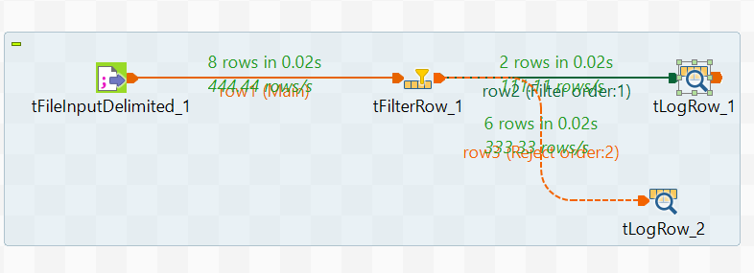

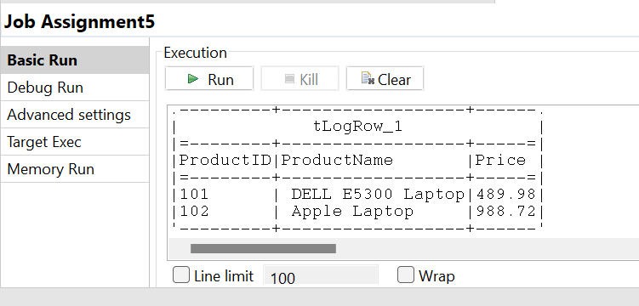

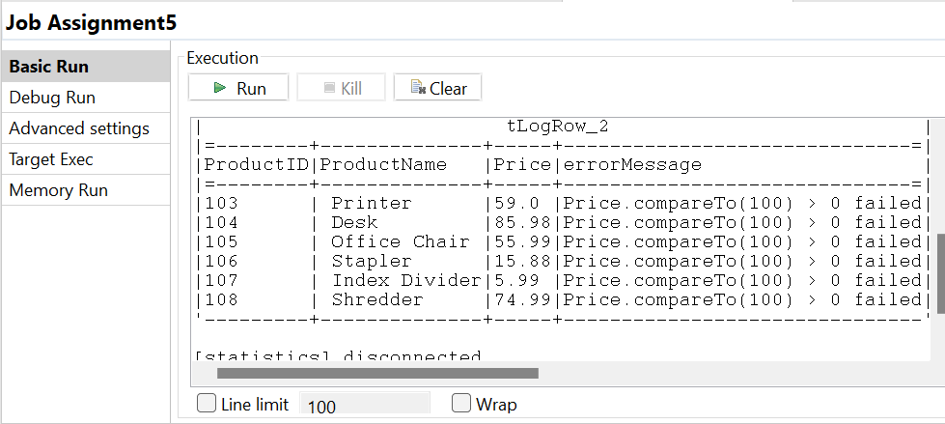

| tLogRow_1 |

|=--------+------------------+-----=|

|ProductID|ProductName |Price |

|=--------+------------------+-----=|

|101 | DELL E5300 Laptop|489.98|

|102 | Apple Laptop |988.72|

'---------+------------------+------'

tLogRow_2 |

|=--------+--------------+-----+------------------------------=|

|ProductID|ProductName |Price|errorMessage |

|=--------+--------------+-----+------------------------------=|

|103 | Printer |59.0 |Price.compareTo(100) > 0 failed|

|104 | Desk |85.98|Price.compareTo(100) > 0 failed|

|105 | Office Chair |55.99|Price.compareTo(100) > 0 failed|

|106 | Stapler |15.88|Price.compareTo(100) > 0 failed|

|107 | Index Divider|5.99 |Price.compareTo(100) > 0 failed|

|108 | Shredder |74.99|Price.compareTo(100) > 0 failed|

'---------+--------------+-----+-------------------------------

d. Sort the records from Product by Product name in descending order. Output the results in tLogRow3 table.

e. Take a screenshot of the executed job and paste it here; Copy and paste the table result from d here.

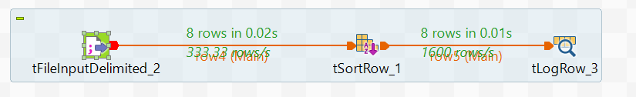

tLogRow_3 |

|=--------+------------------+-----=|

|ProductID|ProductName |Price |

|=--------+------------------+-----=|

|106 | Stapler |15.88 |

|108 | Shredder |74.99 |

|103 | Printer |59.0 |

|105 | Office Chair |55.99 |

|107 | Index Divider |5.99 |

|104 | Desk |85.98 |

|101 | DELL E5300 Laptop|489.98|

|102 | Apple Laptop |988.72|

'---------+------------------+------'

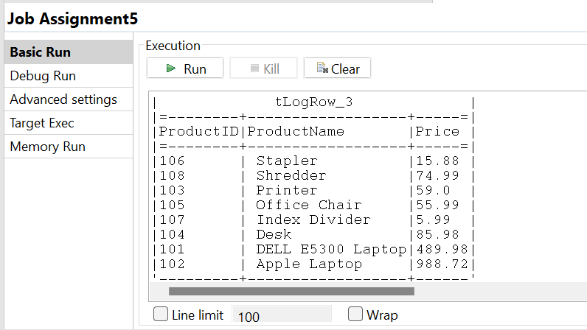

Task 2: Inner Join and Integration

a. Import Product.csv and Orderline.csv into the Talend data studio job.

b. In one tLogRow table, output a table containing the matched records from Product and Orderline, with columns “ProductID”, “ProductName”, “Price” from Product, and columns “OrderID”, “Quantity” from Orderline.

c. In another tLogRow table, output a table containing Product records that have not been purchased in any of the orders. Include “ProductID”, “ProductName”, “Price” from Product, and “OrderID”, “Quantity” from Orderline in the output table.

d. Take a screenshot of the executed job and paste it here; Copy and paste both table results from b and c here.

Task 3: Left Join and Aggregation

a. Import Product.csv and Orderline.csv into the Talend data studio job.

b. In the tLogRow table, output all records from Orderline and their corresponding records from Product, with columns “OrderID”, “ProductID”, “Quantity” from Orderline, and “ProductName” and “Price” from Product.

c. Aggregate the OverallQuantitybyOrder by summing the quantities from the same order (Order ID) and add OverallQuantitybyOrder further into the output table from b.

d. Take a screenshot of the executed job and paste it here; Copy and paste the table results from c here.

Task 4: Data Warehouse

a. Use metadata to connect to Microsoft SQL server and the database: “AdventureWorksDW2017”;

b. Import “DimProduct”, “DimDate” and “FactProductInventory” tables into the job.

c. Match the key values in these tables, and generate a output table “ProductBalanceAfter2013” with the matching records and columns “ProductKey”, “DateKey” and “UnitsBalance” from FactProductInventory table, “EnglishProductName” from DimProduct table, and “CalendarYear” from DimDate table.

d. Set a filter, so that only records later than year 2013 are included in this output table.

e. Export this table to the database: “AdventureWorksDW2017”.

f. Take a screenshot of the executed job and paste it here. Use query to check the first 10 records from the table “ProductBalanceAfter2013” and paste it here.